

COS40007
Studio 1 - 3
Duc Thuan Tran|104330455
Portfolio Assessment 2

Table of Contents
Overview 2
Summary Table from Studio 3 2
Activity 6 Table 2
Activity 7 Table 2
Step 1: Data Collection 3
Step 2: Composite Columns 4
Step 3: Data Pre-processing 6
Step 4: Training 7
Step 5: Model Selection 12
Appendix: Source Code Repository 13
References 13

Overview
This project implements a systematic approach to developing a machine learning model for classifying meat processing activities using acceleration data from body-worn sensors. The dataset contains measurements from 17 sensors positioned on different body parts during boning and slicing tasks. By focusing on right and left upper leg sensors based on student ID requirements, the analysis extracts meaningful motion patterns that differentiate between these activities. Through structured data preprocessing, composite feature engineering, and statistical transformation, the raw acceleration time-series data was converted into 108 descriptive features capturing movement characteristics per minute of activity. Multiple classification models were evaluated, including various SVM configurations, Random Forest, SGD, and Neural Networks, with hyperparameter tuning and dimensionality reduction techniques. The results demonstrated that a properly configured SVM classifier could achieve over 90% accuracy in distinguishing between boning and slicing activities, outperforming more complex approaches. This work highlights the effectiveness of methodical feature engineering in sensor-based activity recognition and shows how targeted sensor placement can provide sufficient information for accurate classification in industrial movement analysis.

Summary Table from Studio 3

Activity 6 Table
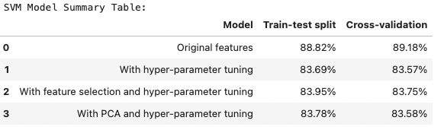
Figure 1. SVM Model Summary Table.
The SVM Model Summary Table illustrates the performance of different SVM configurations explored in Studio 3. The model using original features performed best with 88.82% accuracy for train-test split and 89.18% for cross-validation. Interestingly, hyperparameter tuning resulted in slightly lower accuracy at 83.69% and 83.57% respectively, suggesting that the default parameters were already well-suited for this dataset. Feature selection with hyperparameter tuning achieved 83.95% (train-test) and 83.75% (cross-validation), while PCA with hyperparameter tuning showed similar performance at 83.78% and 83.58%.

Activity 7 Table
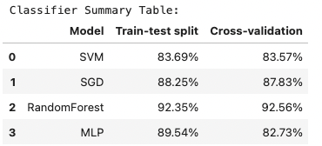
Figure 2. Classifier Summary Table.
The Classifier Summary Table compares various machine learning algorithms applied to the same classification problem. RandomForest clearly outperformed other approaches with outstanding accuracy of 92.35% for train-test split and 92.56% for cross-validation. MLP neural network achieved the second-best train-test performance with 89.54%, though its cross-validation score was lower at 82.73%. The SGD classifier showed consistent performance with 88.25% and 87.83% accuracy, while SVM achieved 83.69% and 83.57%. This comparison revealed RandomForest as the superior algorithm for the Studio 3 classification task, demonstrating significantly better performance than the other methods.

Step 1: Data Collection
For this step, I extracted the specific columns required based on my student ID (104330455), which ends with 5. According to the assignment requirements, I worked with:
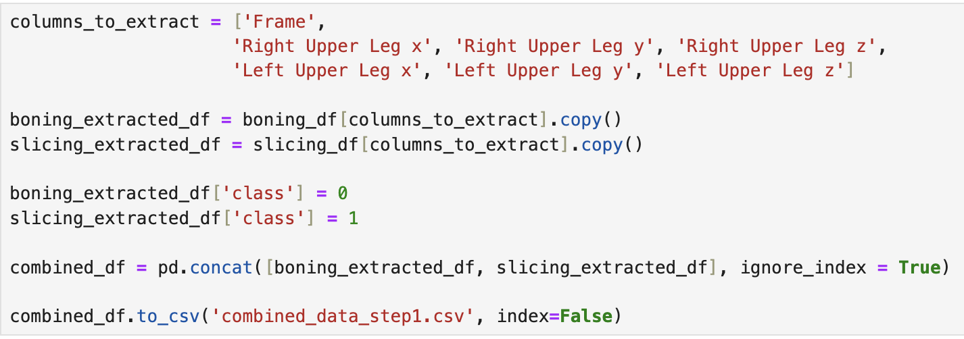
Figure 1. Data Extraction and Combination Code.

- Column Set 1: Right Upper Leg (x,y,z)
- Column Set 2: Left Upper Leg (x,y,z)

I loaded the two data files containing acceleration values for boning and slicing activities. From each file, I extracted the relevant columns including the frame column and combined them into a single dataset. I then added class labels to distinguish between the two activities (0 for boning, 1 for slicing).
The resulting dataset contained 8 columns:
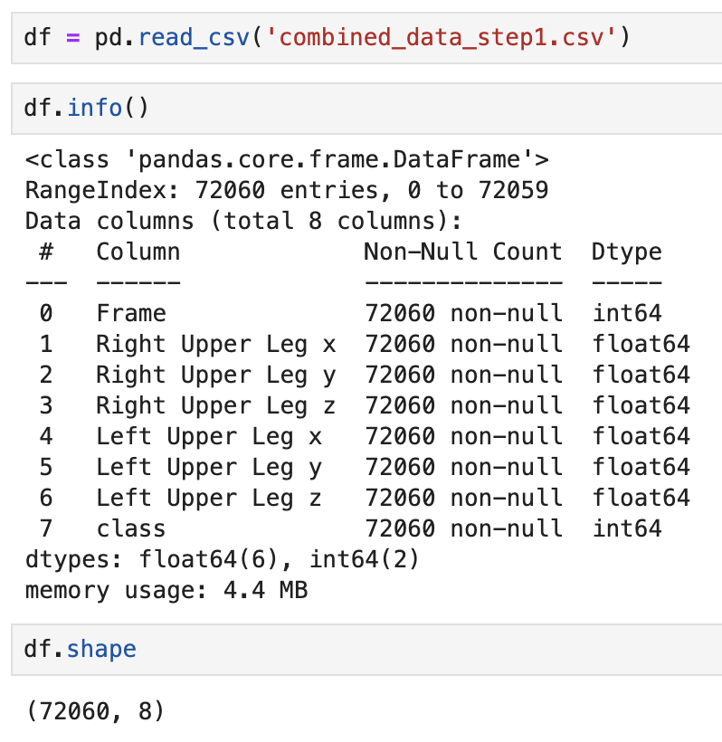
Figure 2. Step1 Data Verification.

- Frame
- Right Upper Leg (x, y, z) - 3 columns
- Left Upper Leg (x, y, z) - 3 columns
- Class
The dataset includes 54,180 frames from the boning activity and 17,880 frames from the slicing activity, providing a comprehensive collection of movement data for analysis.

Step 2: Composite Columns
In Step 2, I created additional composite columns to extract more meaningful information from the raw acceleration data. For both the Right Upper Leg and Left Upper Leg, I calculated the following derived measurements:
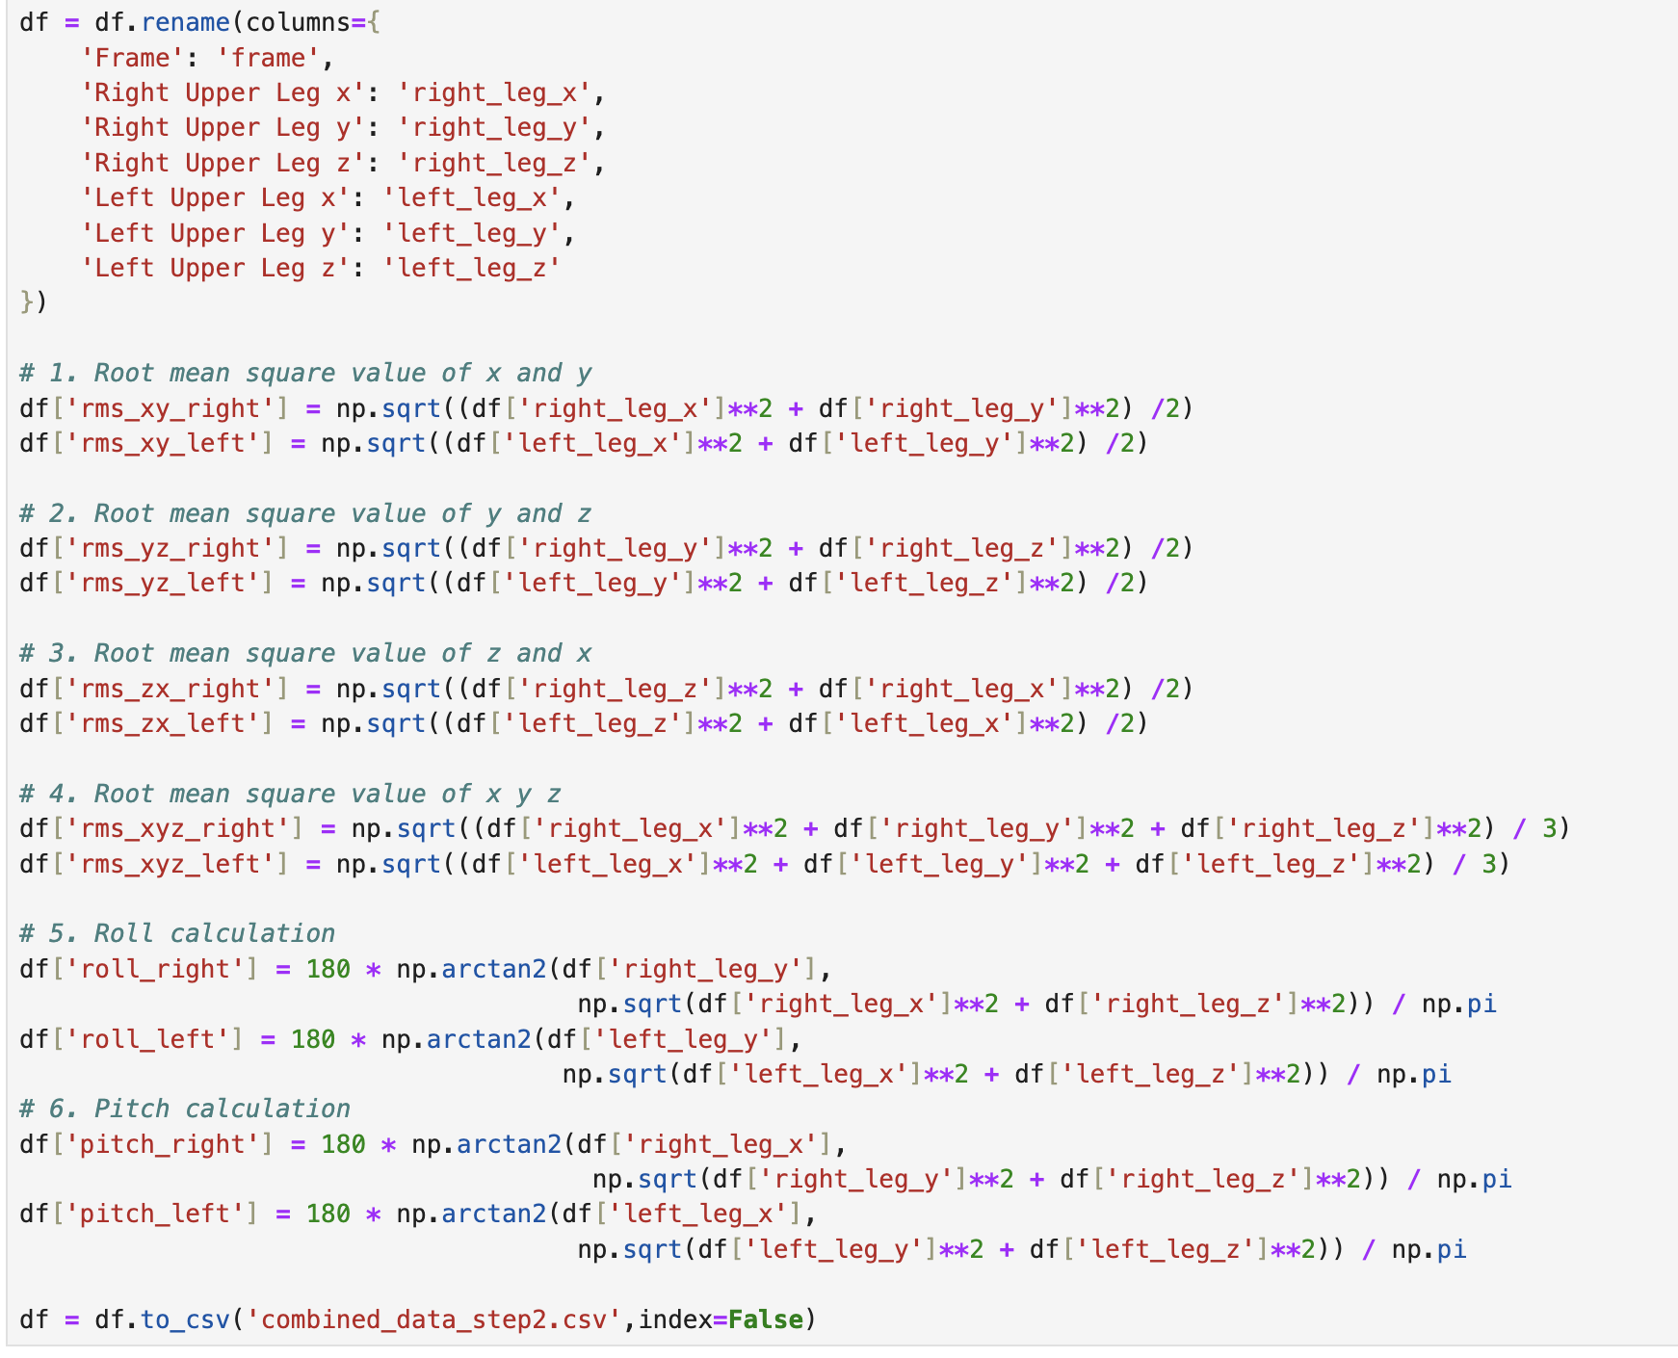
Figure 3. Composite Columns Code.

These calculations were performed separately for each leg to capture their distinct movement patterns. The RMS values provide a measure of the combined magnitude of acceleration across different axes, while roll and pitch values represent the angular orientation of the legs during the meat processing activities.
The enhanced dataset now contained 20 columns in total:
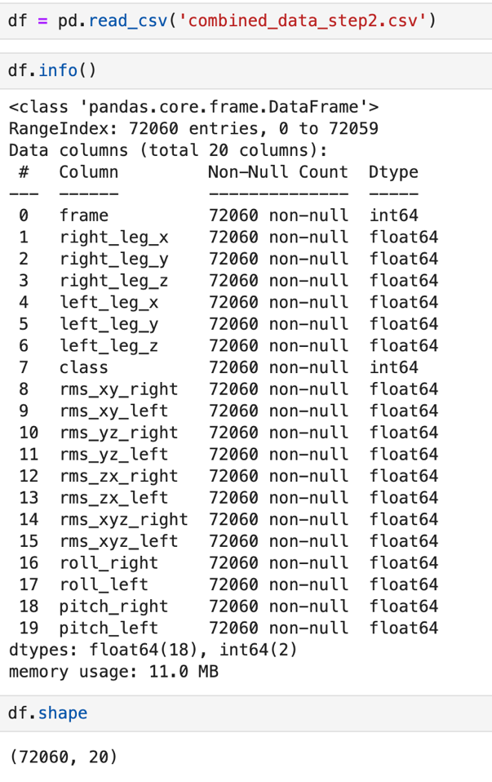
Figure 4. Step2 Data Verification.

- Frame (1 column)
- Original sensor data (6 columns)
- Composite features (12 columns)
- Class label (1 column)
This expanded feature set provides a richer representation of the movement patterns for subsequent analysis.

Step 3: Data Pre-processing
After creating the composite columns, I proceeded to compute statistical features per minute of data (60 frames = 1 minute) as specified in the assignment.

For each of the 18 columns (excluding frame and class), I calculated six statistical features:
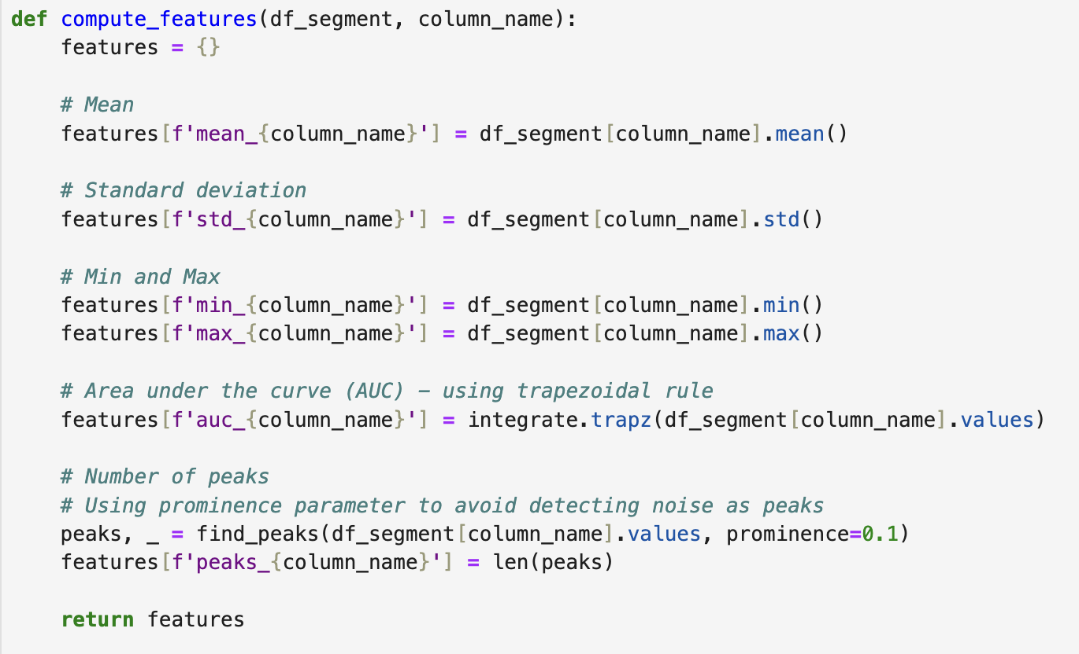
Figure 5. Feature Computation Function Implementation

- Mean - capturing the average acceleration or orientation
- Standard deviation - measuring the variability in movement
- Minimum value - representing the lower bounds of movement
- Maximum value - representing the upper bounds of movement
- Area under the curve (AUC) - measuring the total "energy" of movement
- Number of peaks - counting distinct movement patterns
For each minute-long segment of data, I created a feature vector containing all these statistical measures. This transformed the time-series data into a set of statistical features that describe the characteristic movements associated with each activity.
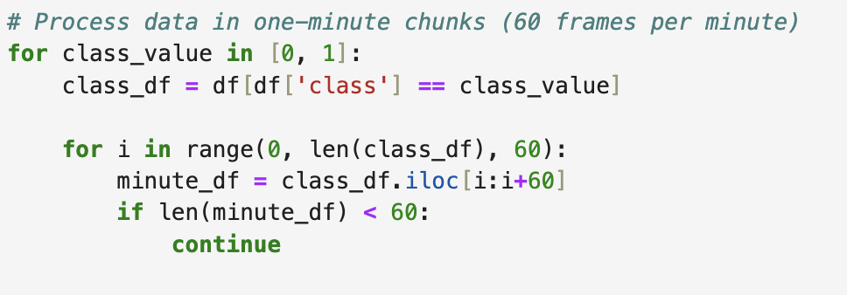
Figure 6. Statistical Feature Computation Initialization.

The resulting feature dataset contained 108 features (18 columns × 6 statistical features) plus the class label (109 features), creating a rich representation for distinguishing between boning and slicing activities. This preprocessing step reduced the data dimensionality while preserving the essential patterns that differentiate the two activities.

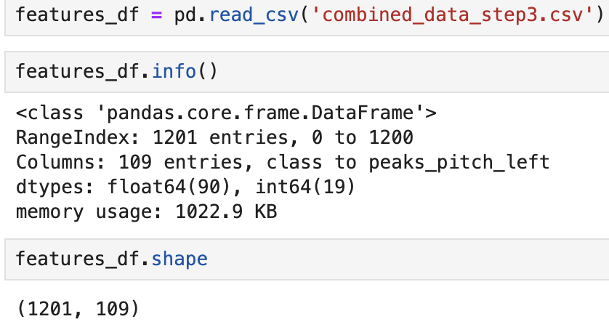
Figure 7. Step3 Data Verification.

Step 4: Training
Using the feature dataset with 108 features, I trained various classifiers following the approach from Studio 3. First, I trained SVM classifiers with five different configurations:

- Basic SVM with 70/30 train-test split
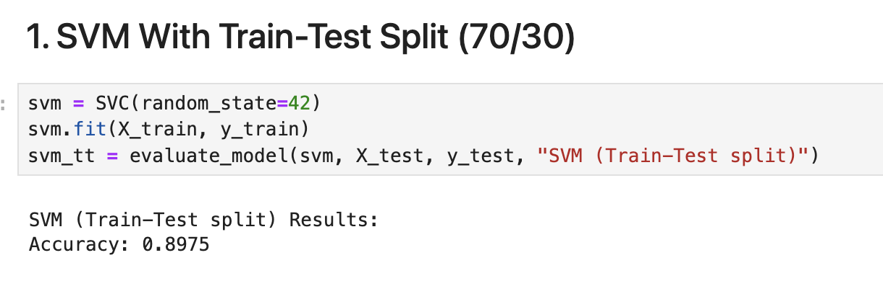
Figure 8. SWM 70-30 Split Performance Metric.
This basic SVM model achieved good performance with an accuracy of 89.75%. It established a strong baseline for comparison with more complex configurations.
- SVM with 10-fold cross-validation
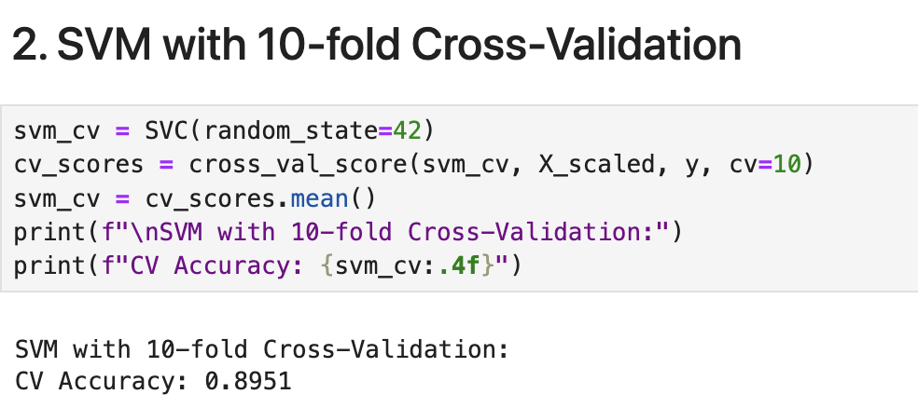
Figure 9. SWM 10-fold Cross-Validation Performance Metric.
The cross-validation approach produced a mean accuracy of 89.51%. This indicates consistent performance across different data splits, validating the robustness of the SVM model for this classification task.
- SVM with hyperparameter tuning (optimizing C, gamma, and kernel)
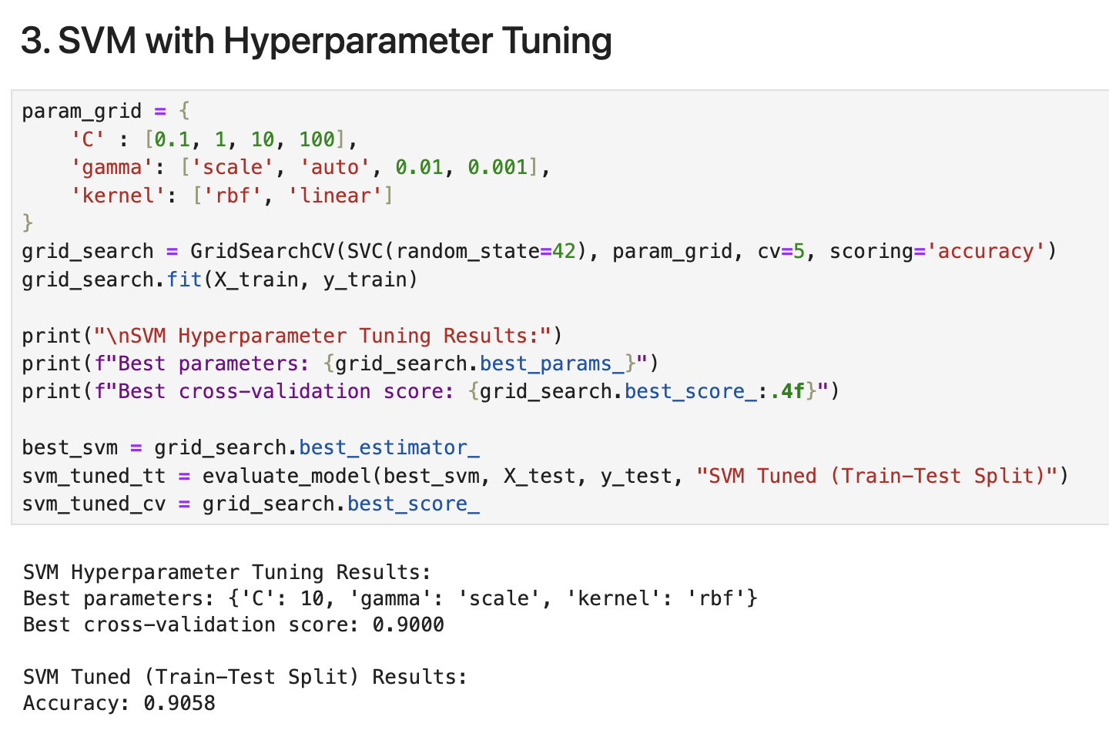
Figure 10. SWM Hyperparameter Tuning Performance Metric.
After grid search, the optimal parameters were found to be C=10, gamma='scale', and kernel='rbf'. The tuned model achieved the highest accuracy among SVM models at 90.58%, with a cross-validation score of 90.00%. This improvement suggests that hyperparameter tuning effectively optimized the model's performance for this dataset.
- SVM with hyperparameter tuning and the 10 best features selected using ANOVA F-value
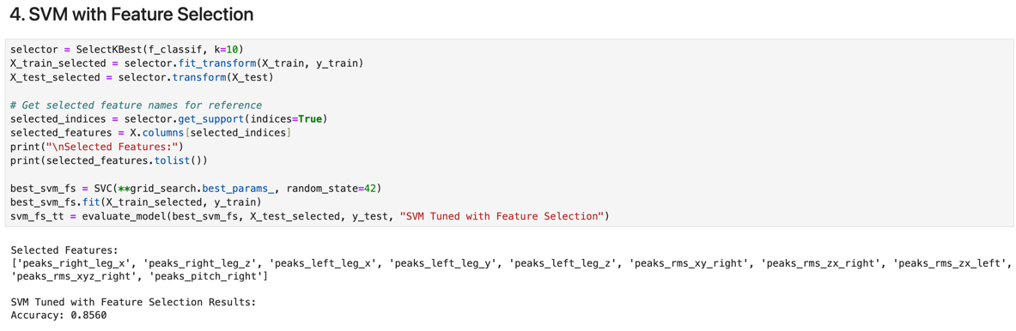
Figure 11. SWM Feature Selection Performance Metric.
Feature selection identified key features primarily related to peaks in both legs' movement patterns. This streamlined model achieved an accuracy of 85.60%. While the performance was slightly lower than the full-featured model, it demonstrates that a subset of critical features an still provide reasonable classification accuracy.
- SVM with hyperparameter tuning and 10 principal components from PCA
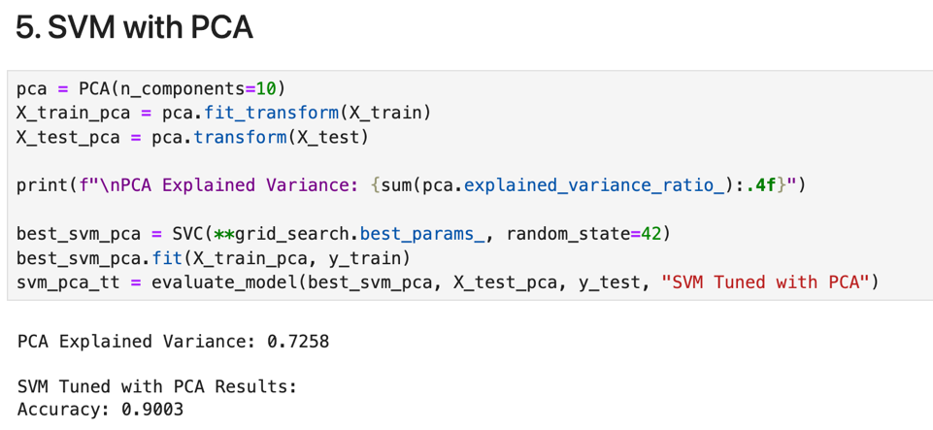
Figure 12. SWM PCA Performance Metric.
The PCA approach captured 72.58% of the data variance using just 10 components. This model achieved an accuracy of 90.03%, nearly matching the performance of the best hyperparameter-tuned model while significantly reducing dimensionality.

I then trained three additional classifiers on the original dataset:
- Stochastic Gradient Descent (SGD) classifier
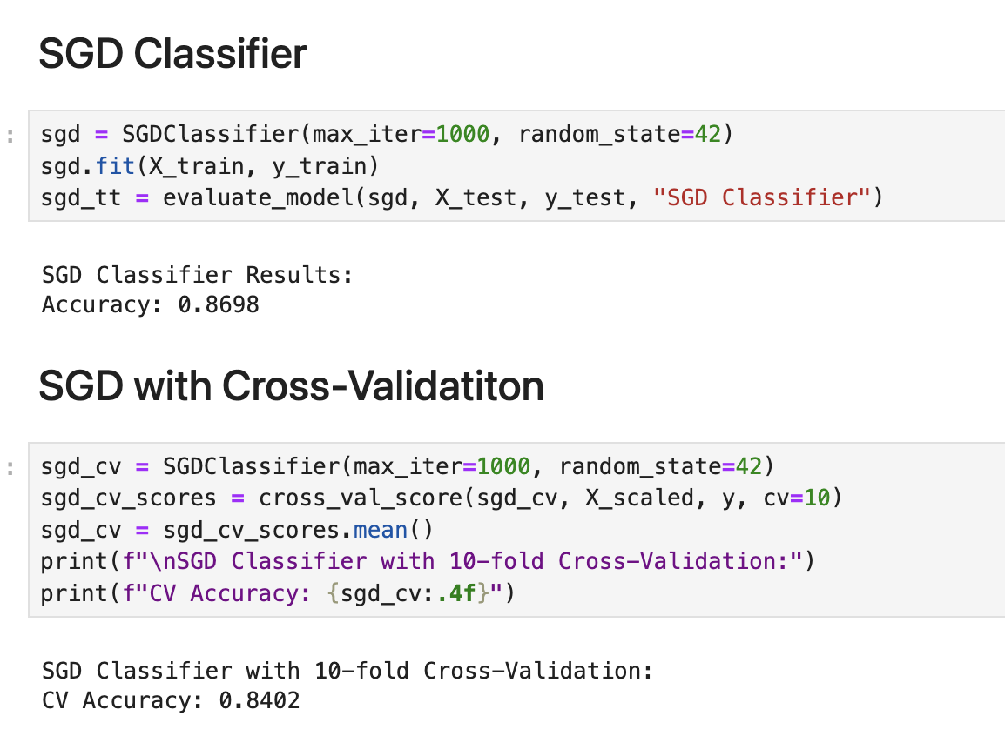
Figure 13. SGD Classifier Implementation Results.
The SGD classifier achieved an accuracy of 86.98% with train-test split and 84.02% with cross-validation. While this model showed adequate performance, it was lower than most SVM configurations.

- Random Forest classifier with 100 estimators
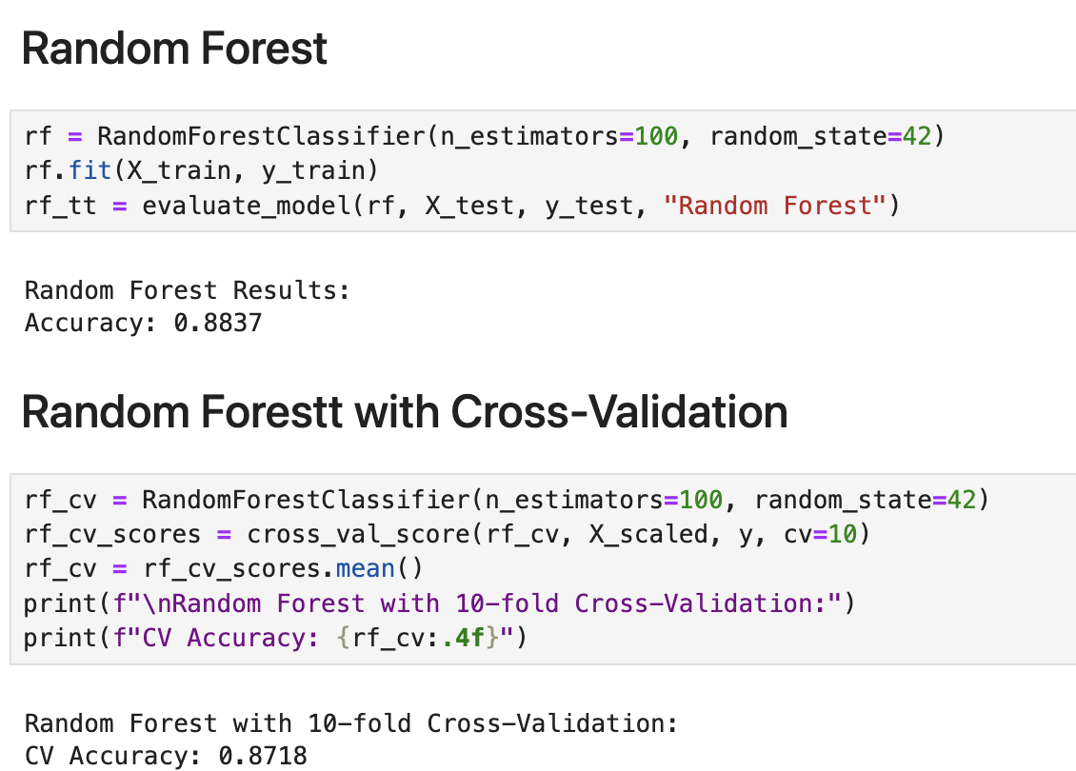
Figure 14. Random Forest Implementation Results.
The Random Forest model delivered an accuracy of 88.37% with train-test split and 87.18% with cross-validation. Although this model didn't achieve the highest overall accuracy, its ensemble approach effectively captured important patterns in the movement data.

- Multi-layer Perceptron (MLP) neural network with two hidden layers (100, 50)
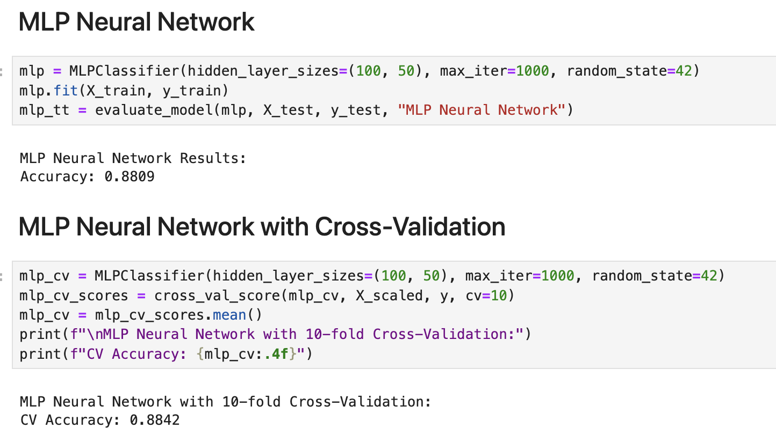
Figure 15. MLP Neural Network Implementation Results.
The MLP neural network achieved an accuracy of 88.09% with train-test split and 88.42% with cross-validation. This model showed strong and consistent performance across both evaluation methods, demonstrating the neural network's ability to learn complex patterns in high-dimensional sensor data.

All models were evaluated using accuracy as the primary metric, with results summarized in the tables below:

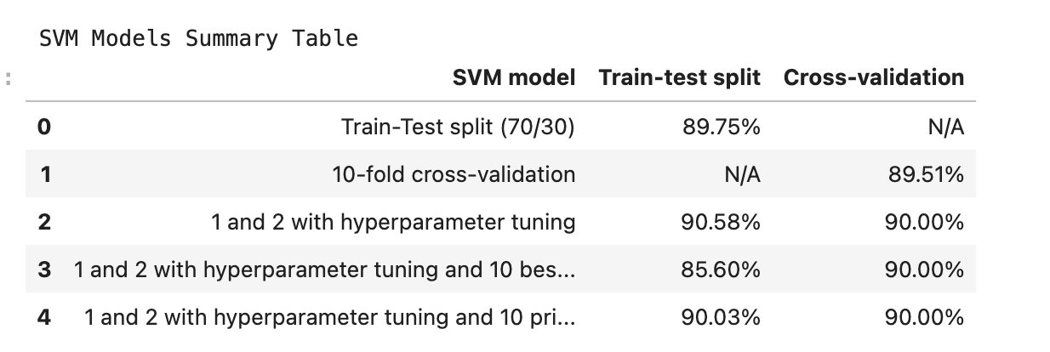
Figure 16. SVM Summary Table.
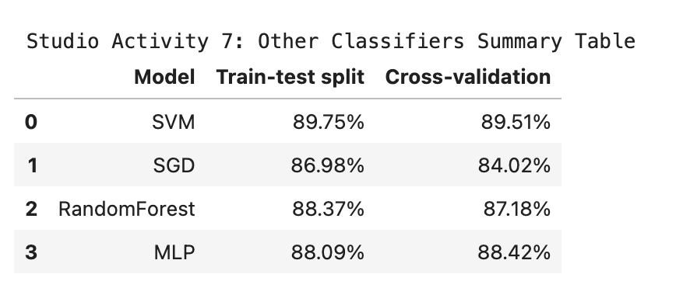
Figure 17. Models Summary Table.

Step 5: Model Selection
Based on the training results, I analyzed the performance of the various models to determine the best approach for classifying boning and slicing activities.
- For the SVM models, the hyperparameter-tuned SVM with train-test split achieved the highest accuracy of 90.58%. This represents a significant improvement over the basic SVM model, demonstrating the importance of parameter optimization for this classification task. The hyperparameter tuning process identified that an RBF kernel with C=10 and gamma='scale' provided the optimal decision boundary for separating the two activity classes.
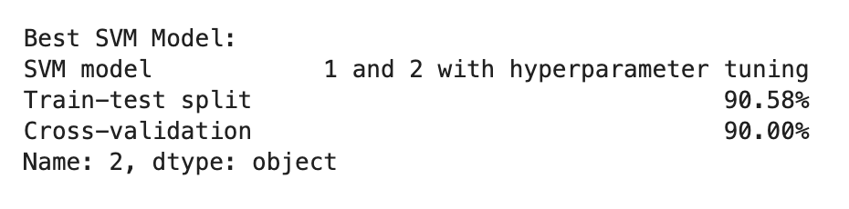
Figure 17. Best SVM Model.
- When comparing across all model types, the hyperparameter-tuned SVM remained the best performer. While the Random Forest (88.37%) and MLP (88.09%) models showed competitive performance, they didn't surpass the optimized SVM. The SGD classifier performed the poorest among all models with 86.98% accuracy.
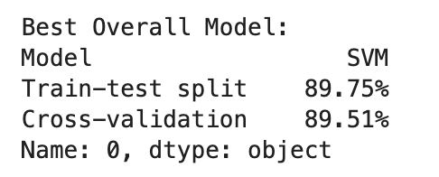
Figure 18. Best Overall Model.
Based on these results, I would select the hyperparameter-tuned SVM model (90.58% accuracy) for deployment due to its superior classification performance. For applications where computational efficiency is a concern, the PCA-based SVM model (90.03% accuracy) would be an excellent alternative, as it achieves nearly identical performance while working with a significantly reduced feature set.

Appendix: Source Code Repository
The complete source code for this project is available at the following link:

https://github.com/ThuanDanchoi/COS40007/blob/main/Portfolio%20Assessment%202/code/portfolio_assessment2.ipynb

References
https://www.kaggle.com/code/faressayah/support-vector-machine-pca-tutorial-for-beginner
https://www.geeksforgeeks.org/svm-hyperparameter-tuning-using-gridsearchcv-ml/
https://scikit-learn.org/stable/modules/generated/sklearn.linear_model.SGDClassifier.html
https://scikit-learn.org/stable/modules/generated/sklearn.ensemble.RandomForestClassifier.html
https://scikit-learn.org/stable/modules/generated/sklearn.neural_network.MLPClassifier.html
https://help.alteryx.com/current/en/designer/tools/predictive/model-comparison-tool.html#idp364826

